Blood and Bone Marrow Morphology
Oberley

1.
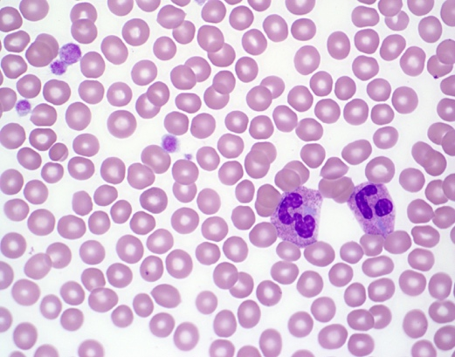

The patient is a 6-year-old boy referred to a hematologist for thrombocytopenia. The patient has no personal or family history of bleeding. His only other past medical history is mild high-frequency hearing loss.

What gene is responsible for these findings?

A. NBEAL2
B. GP-1Ba
C. MYH9
D. Deletions of long arm of chromosome 11
E. GATA1

Explanation
The peripheral blood smear shows macrothrombocytopenia with otherwise normal platelet granulation. The neutrophils have prominent Döhle-like cytoplasmic inclusions. The smear is consistent with May-Hegglin anomaly, caused by mutations in MYH9. MYH9-related diseases include Epstein syndrome, Fechtner syndrome, and May-Hegglin anomaly. Other genetic syndromes associated with giant platelets include
- Bernard-Soulier (GP-1Ba)
- Gray platelet syndrome (NBEAL2)
- Some patients with von Willebrand factor type 2b
- Paris-Trousseau thrombocytopenia (deletion of 11q23 terminus)

2.
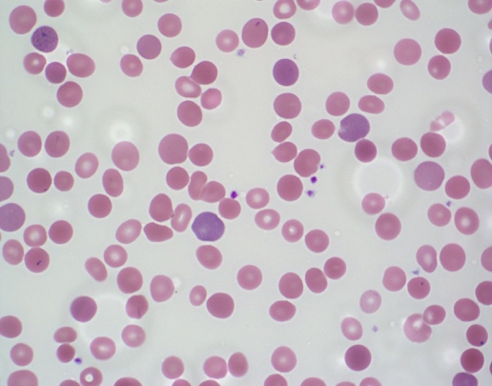

A 4-year-old boy is pale with intermittent jaundice and splenomegaly. His lab results reveal RBC 4.85 M/µL (N), Hgb 8.6 g/dL (L), Hct 25.8% (L), MCV 81.6 (N), MCHC 38% (H), RDW 20% (H), retic. 7% (H).

What are the two best tests to distinguish autoimmune hemolytic anemia from hereditary spherocytosis?

A. Free erythrocyte protoporphyrin and IgG levels
B. Hemoglobin electrophoresis and direct antiglobulin test (DAT)
C. LDH and modified Russell viper venom test
D. RDW and MCHC
E. DAT and osmotic fragility testing

Explanation
The findings on the peripheral blood smear include small, dense, round microspherocytes, polychromasia, and red cells with central pallor that is often smaller than normal. In this case, the DAT was negative, and the patient was diagnosed with hereditary spherocytosis. A high MCHC (36 g/dL or higher) is consistent with the presence of spherocytes.

Free erythrocyte protoporphyrin testing is useful is the evaluation of porphyrias. Hemoglobin electrophoresis is useful in the evaluation of hemoglobinopathies. The modified Russell viper venom test is useful in the evaluation of lupus anticoagulant.

Hereditary spherocytosis is caused by mutations in membrane skeletal proteins Ankyrin-1, α-spectrin, β-spectrin, band 3, or erythrocyte membrane protein band 4.2. Hereditary elliptocytosis is typically caused by heterozygous mutations in α-spectrin, β-spectrin, or protein 4.1. Hereditary pyropoikilocytosis is typically caused by homozygous mutations in α-spectrin, β-spectrin, or protein 4.1.

3.
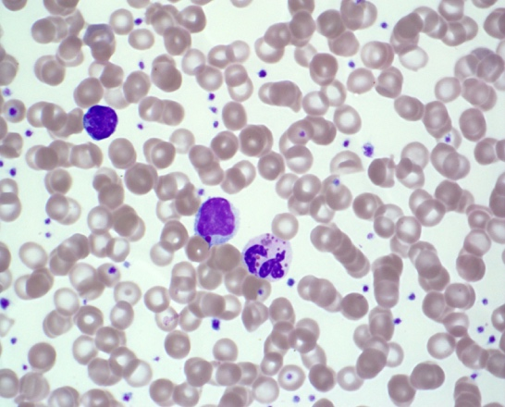

The patient is a 2-month-old boy who presented with a skin abscess and is febrile. On exam he is noted to have silvery hair and hypopigmented skin. A CBC shows a leukocyte count of 3.4 K/µL with 10% neutrophils. What does the abnormality on the peripheral smear suggests?

A. Abnormal lysosomal biogenesis
B. Abnormal ribosome function
C. Abnormal phagocytosis of opsonized particles
D. Abnormal mitochondrial activity
E. Impaired DNA repair activity

Explanation
The peripheral blood smear shows abnormally large azurophilic or gray granules in the neutrophils and lymphocytes. These abnormal coalesced lysosomes can be found in all leukocytes. Chediak-Higashi syndrome is caused by abnormal lysosomal biogenesis. Patients in the stable phase have increased susceptibility to infection, easy bruising, and oculocutaneous albinism. An accelerated phase with hemophagocytic lymphohistiocytosis is typically fatal.

Of the other choices, the following diseases are examples that have defects in the cellular system named:
- Diamond Blackfan anemia, characterized abnormal ribosomal function
- Leukocyte adhesion deficiency, characterized by abnormal phagocytosis
- Pearson syndrome, characterized by abnormal mitochondrial activity
- Ataxia telangiectasia, characterized by abnormal DNA repair

4.
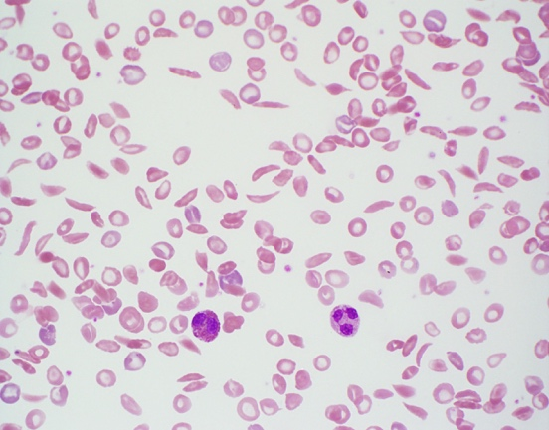

Which of the following tests can provide a diagnosis for the disease process shown in the peripheral blood smear above?

A. CBC with differential
B. G6PDH activity levels
C. High-performance liquid chromatography (HPLC)
D. Osmotic fragility testing
E. Reticulocyte count

Explanation
The peripheral blood smear shows a severe sickling crisis, seen in patients with S/S or S/β⁰ genotypes. Substitution of the normal hydrophilic glutamic acid residue for the hydrophobic valine residue leads to pathologic polymerization when deoxygenated. Patients with sickle cell trait do not typically show any sickling on a peripheral blood smear but are solubility test positive. Osmotic fragility is not increased by sickled cells and can be decreased in patients with sickle cell disease after splenectomy. HPLC is commonly used for the detection of hemoglobin variants.

5.
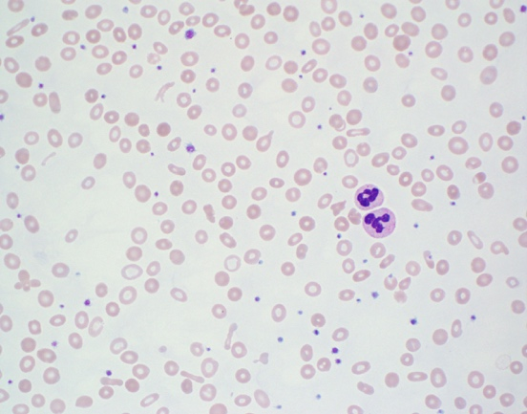

A 3-month-old girl presents with persistent microcytic anemia even with iron supplementation. Which of the following genetic alterations is consistent with the peripheral smear findings?

A. Mutations in RPS19 gene
B. Mutations in codanin-1
C. Homozygous deletion of TMPRSS6 gene (matriptase-2 protein)
D. Transcobalamin II deficiency (TCN2 mutations)
E. Dihydrofolate reductase deficiency

Explanation
The peripheral smear shows hypochromic microcytic anemia with anisopoikilocytosis. Elliptical (pencil) cells are present. There is mild thrombocytosis. These findings are consistent with iron deficiency anemia. This case is consistent with iron-refractory iron deficiency anemia. Matriptase-2 normally reduces hepcidin protein expression by suppressing hemojuvelin. Loss of matriptase-2 leads to increased hepcidin, which limits dietary iron absorption and causes iron sequestration. All of the other mutations are associated with macrocytosis:
- RPS19 mutations cause Diamond-Blackfan anemia.
- Codanin-1 mutations cause congenital dyserythropoietic anemia (type 1).
- Transcobalamin II deficiency and dihydrofolate reductase deficiency both cause megaloblastic anemia.

6.
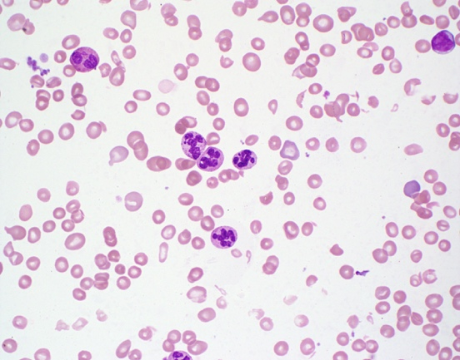

A 3-year-old boy presents with the finding shown in the smear. Which of the following nutritional deficiencies, if present, would explain the smear findings?

A. Cobalamin
B. Cholecalciferol
C. Thiamine
D. Vitamin K
E. α-Tocopherol

Explanation
The peripheral blood smear shows hypersegmented neutrophils and mild macrocytosis with occasional ovalocytes. These finding are consistent with megaloblastic anemia caused by folate or cobalamin deficiency.

7.

In January, a 16-year-old girl travels on a mission trip with her family to Nigeria. Upon her return she reports episodic fevers. The laboratory technician calls you over to show you her findings.

What is the mostly likely identification of these inclusions?

A. Kayser-Fleischer rings
B. Heinz bodies
C. Cabot rings
D. Babesia microti
E. Malaria organisms

Explanation
These inclusions are Plasmodium species. To speciate, look for morphologically characteristic extracellular schizonts and gametocytes. Cabot rings are rarely seen remnant microtubules of the mitotic spindle, which can be seen with megaloblastic anemia, congenital dyserythropoietic anemia, or myelodysplastic syndromes. Babesia organisms are ring shaped intraerythrocytic organisms transmitted by the Ixodes scapularis tick, found in the midwestern and southeastern United States.

8.
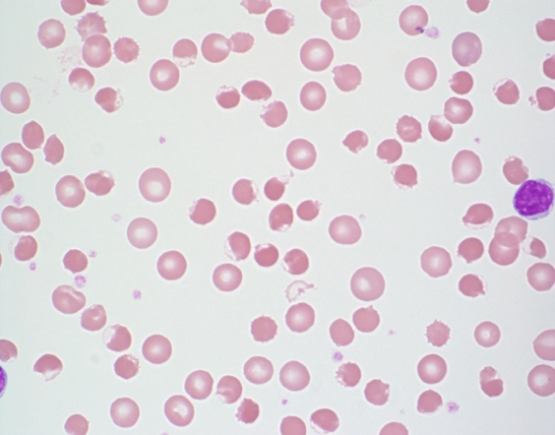

A 14-month-old African American boy presents with sudden onset of pallor, irritability, and dark-colored urine. A CBC is notable for a hemoglobin level of 6.0 g/dL.

With which of the following are the findings on the peripheral smear consistent?

A. Hereditary spherocytosis
B. Neuroacanthocytosis
C. Glucose 6-phosphate dehydrogenase (G6PDH) deficiency
D. Autoimmune hemolytic anemia
E. Thermal injury

Explanation
The findings on the peripheral smear are consistent with G6PDH deficiency. There are numerous blister cells on the smear (eccentrocytes). Blister cells are formed by disruption of the cell membrane during removal of precipitated oxidized hemoglobin (Heinz bodies), followed by reattachment of the two ends of the membrane with vacuole formation. Bite cells also are seen in G6PDH deficiency through removal of oxidized precipitated hemoglobin without vacuole formation.

9.
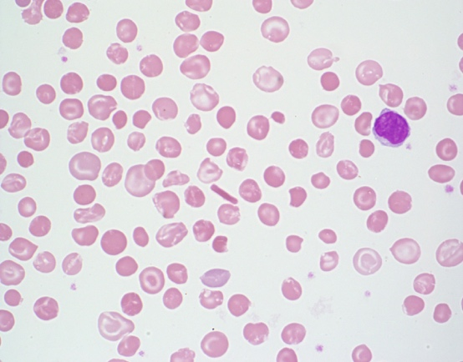

A 16-year-old boy from West Africa is referred to a local hematologist because of anemia and splenomegaly. A CBC shows a hemoglobin of 10.2 g/dL, MCV of 75 fL, reticulocyte count of 152 k/µL, and mean corpuscular hemoglobin concentration (MCHC) of 39%. The patient’s smear is consistent with what genotype?

A. Hemoglobin S trait
B. Hemoglobin S/C disease
C. Hemoglobin C trait
D. Hemoglobin C disease
E. Hemoglobin E

Explanation
The peripheral smear is consistent with hemoglobin C disease. There are target cells, microcytosis, and reticulocytosis. There is a hemoglobin C crystal present in the center of the field. Hemoglobin C is caused by mutation of the hemoglobin beta chain, which is less soluble than the normal beta chain and leads to crystallization. The crystals lead to red cell rigidity and decreased survival time. Hemoglobin C, by itself, does not polymerize or cause sickling. Both heterozygous and homozygous hemoglobin C variants can lead to dehydration of the red cells and consequent increase of the MCHC. Hemoglobin C trait usually does not cause anemia.

10.
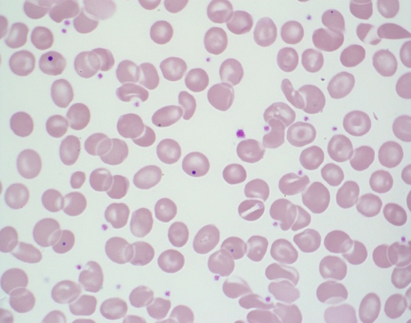

The patient is a 12-year-old boy with anemia who has undergone splenectomy. As you review a peripheral smear, you notice intracellular red cell inclusions.

What kind of inclusion is depicted on the slide, and what material is the inclusion made from?

A. Pappenheimer body, iron-protein complexes in lysosomes
B. Pappenheimer body, DNA (nuclear remnant)
C. Howell-Jolly body, DNA (nuclear remnant)
D. Howell-Jolly body, aggregated ribosomes with incomplete RNA degradation
E. Basophilic stippling, iron-protein complexes in lysosomes

Explanation
Howell-Jolly bodies consist of retained nuclear material and are visualized with Wright-Giemsa staining. They are small purple or purple-blue staining round objects of variable size. There is usually one per cell, but sometimes there are two or more per cell. Clinical conditions associated with Howell-Jolly bodies include
- postsplenectomy
- functional asplenia (eg, sickle cell disease)
- severe hemolytic anemia
- megaloblastic anemia
- congenital dyserythropoietic anemia
- occasionally in newborns especially in those born prematurely.

11.
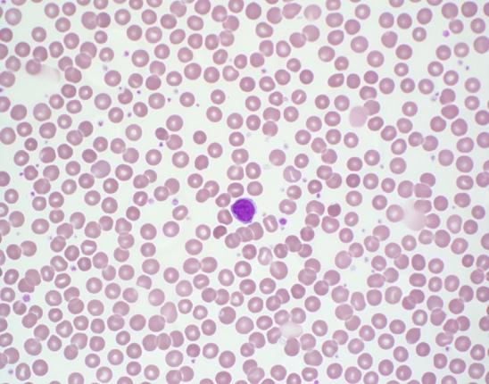

A 2-year-old girl is referred to her local hematologist for suspected anemia. The Hgb is 10.7 g/dL. Which is the most likely diagnosis based on the smear?

A. Hereditary spherocytosis
B. Hereditary elliptocytosis
C. Anemia of inflammation
D. Normal child
E. Hereditary stomatocytosis

Explanation
The peripheral blood smear is normal, and the patient’s hemoglobin level is normal for her age. Various red cell morphologic findings (eg, spherocytosis, stomatocytosis, schistocytes) at levels of 5% or less are commonly seen on normal peripheral blood smears.

12.
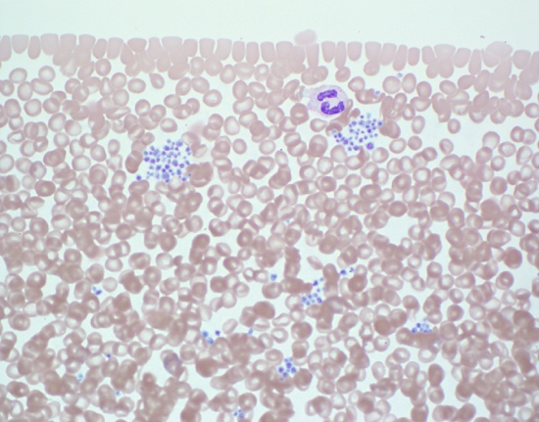

A 12-year-old girl presents with thrombocytopenia (92 k/µL). She has no bleeding history or family history of bleeding. The physician suspects pseudo-thrombocytopenia. What kind of anticoagulant can cause in vitro platelet clumping, and what kind can be used to correct the clumping to get an accurate platelet count?

A. Heparin, EDTA
B. EDTA, citrate
C. Citrate, EDTA
D. Heparin, oxalate
E. Oxalate, citrate

Explanation
The peripheral blood smear shows significant platelet clumping and is otherwise normal. Platelet clumping occurs occasionally with EDTA anticoagulation and will cause a hemocytometer to undercount the number of platelets present. EDTA can also cause platelets to adhere to leukocytes (platelet satellitosis). Drawing a second sample with citrate anticoagulant should prevent clumping and permit a more accurate platelet count.

13.
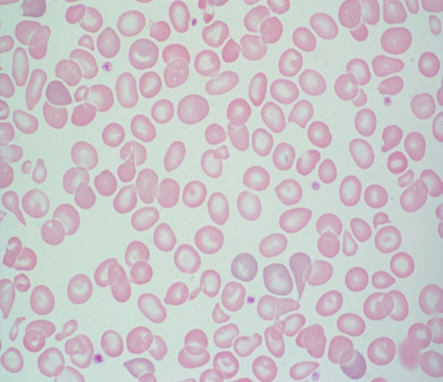

A 1-year-old boy is followed by a hematologist, and a CBC shows Hgb of 8.5 g/dL, mean corpuscular volume (MCV) of 68.3 fL, mean corpuscular hemoglobin concentration (MCHC) 29%, RDW 15.1%, and reticulocyte count of 75 k/µL. High-performance liquid chromatography done at birth showed hemoglobin Barts, and the patient was diagnosed with alpha thalassemia intermedia.

If brilliant cresyl blue staining is done on these red cells, what red cell inclusion is likely to be present?

A. Howell-Jolly bodies
B. Pappenheimer bodies
C. Hemoglobin H inclusions
D. Coarse basophilic stippling
E. Protoporphyrin rings

Explanation
The findings on the peripheral smear include hypochromic microcytic anemia with anisopoikilocytosis, target cells, and basophilic stippling. Hemoglobin H inclusions are precipitates of excess β tetramer chains. They are not visible with Wright-Giemsa staining; supravital dyes such as brilliant cresyl blue must be used. Inclusions appear as numerous small bluish granules distributed evenly throughout the cell. Clinical conditions associated with hemoglobin H inclusions are α-thalassemia with deletion of three of the four genes.

14.
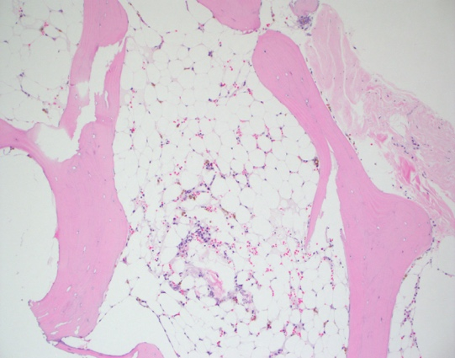

A 17-year-old boy presents with pancytopenia. The bone marrow biopsy is pictured. Cytogenetics show 46,XY, and flow cytometry does not identify a dysplastic cell population. Which of the following statements is true?

A. Evaluation for dyskeratosis congenita includes diepoxybutane (DEB) testing.
B. Performing telomere length studies can diagnose Fanconi anemia.
C. Paroxysmal nocturnal hemoglobinuria (PNH) clones are never present in patients with aplastic anemia.
D. Cell morphology evaluation by electron microscopy is not helpful in the evaluation of aplastic anemia.
E. Presence of a deletion of 20q with karyotypic evaluation is diagnostic of myelodysplastic syndrome (MDS).

Explanation
The bone marrow biopsy is severely hypocellular (5%). With no evidence of cytogenetic abnormality or dysplasia, the biopsy is consistent with aplastic anemia. Workup of aplastic anemia includes evaluation for Fanconi (DEB breakage studies), dyskeratosis congenita (telomere length studies), PNH clones, and hepatitis A/B/C serologies. Electron microscopy is not useful in the evaluation of aplastic anemia. Recurrent karyotypic abnormalities of deletion Y, trisomy 8, and deletion 20q are not considered MDS defining and cannot be used in isolation to make a diagnosis of MDS.

15.
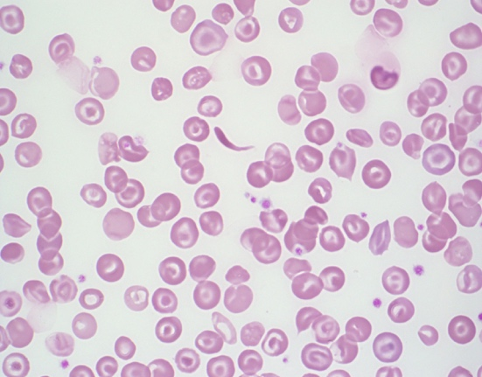

A 5-year-old girl who recently relocated from the Ivory Coast of West Africa is evaluated for anemia. After the hematologist reviews the peripheral blood smear, which of the following is her provisional diagnosis, and what further testing does she order?

A. Hemoglobin SS, osmotic fragility testing
B. Hemoglobin CC, hemoglobin electrophoresis
C. Hemoglobin E, osmotic fragility testing
D. Hemoglobin SC, hemoglobin electrophoresis
E. Hemoglobin H disease, supravital staining

Explanation
The peripheral smear shows normocytic normochromic anemia with many target cells and rare sickled cells. The smear is consistent with hemoglobin SC, and confirmation would be made with hemoglobin electrophoresis. The other choices would present with peripheral smears with more (Hgb SS) or no (Hgb CC, Hgb H, Hgb E) sickle cells.

16.
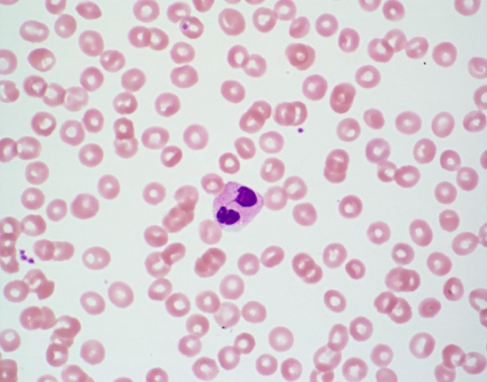

You review a peripheral smear from a healthy 10-year-old boy and find many cells with the morphology of the leukocyte shown. What does this morphology result from?

A. Heterozygous mutations in the lamin B receptor gene
B. Homozygous mutations in the lamin B receptor gene
C. Homozygous mutations in the ELANE gene
D. Heterozygous mutations in the SBDS gene
E. Homozygous mutations in the LYST (CHS1) gene

Explanation
The hyposegmented bilobed neutrophils seen on the peripheral smear in a well child are consistent with Pelger-Huët anomaly. This is caused by mutations in the lamin B receptor. Heterozygotes have bilobed neutrophils, and homozygotes have neutrophils with round unilobed nuclei. Mutations in the ELANE gene are associated with severe congenital neutropenia. SBDS mutations result in Shwachman-Diamond syndrome. LYST mutations result in Chediak-Higashi syndrome.

17.
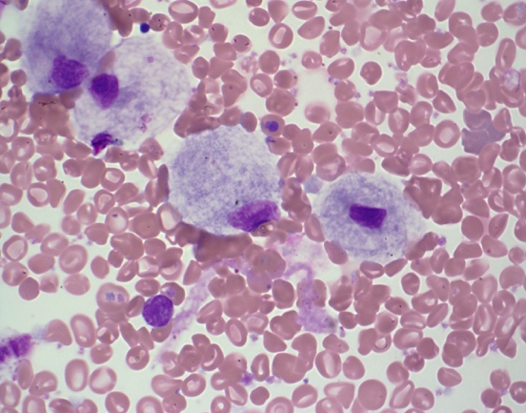

A 10-year-old boy presents with mild anemia and thrombocytopenia. He has bone abnormalities and hepatosplenomegaly on radiographic imaging. Abnormal cells are present on the shown bone marrow aspirate. The molecular defect in this disease results in a deficiency of which enzyme:

A. β-Glucocerebrosidase
B. α-L-iduronidase
C. Lysosomal acid lipase
D. Arylsulfatase A
E. Acid sphingomyelinase

Explanation
The cells on the bone marrow aspirate direct smear are Gaucher cells. Gaucher cells are reticuloendothelial cells of the monocytic lineage with lysosomes stuffed with glycosphingolipids. The cytoplasm of the cells has the characteristic wrinkled tissue paper appearance. This appearance results from the enlarged and misshapen lysosomes. α-L-iduronidase is deficient in mucopolysaccharidosis type I. Lysosomal acid lipase is deficient in Wolman disease and cholesteryl ester storage disease. Arylsulfatase A is deficient in metachromatic leukodystrophy. Acid sphingomyelinase is deficient in Niemann-Pick disease.

18.
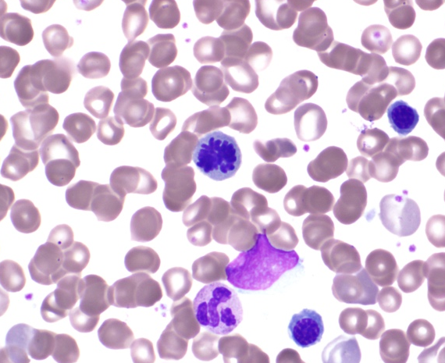

As you review a bone marrow aspirate, you occasionally identify cells with an unusual nuclear configuration. What cellular process is happening?

A. Apoptosis
B. Autophagy
C. Mitosis
D. Karyorrhexis
E. Meiosis

Explanation
The cell in question is a mitotic figure and is seen in cells undergoing mitosis. In mitosis, the chromosomes condense and are individually visible. It is normal to see occasional mitotic figures in healthy marrows. Mitotic figures are greatly increased in neoplastic conditions.

19.

A bone marrow aspirate from an 8-month-old infant who is acutely ill with a ferritin level of 12,000 shows which of the following abnormalities?

A. Myelodysplastic syndrome
B. Leishmaniasis
C. Hemophagocytosis
D. Acute monocytic leukemia
E. Gaucher disease

Explanation
The bone marrow shows hemophagocytosis, and the patient should be worked up for hemophagocytic lymphohistiocytosis. The macrophage in the left panel has engulfed mature red blood cells, platelets, and cellular debris. The macrophage in the right panel has engulfed a neutrophil and an immature red cell.

20.
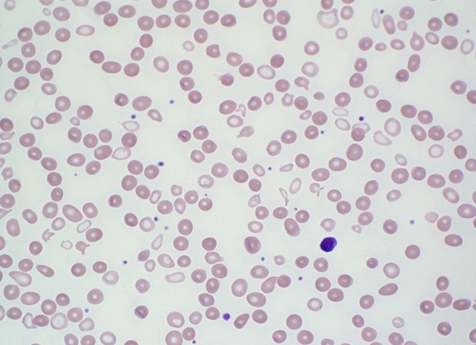

A 10-year-old boy is evaluated for progressive anemia and is noted to have Hgb of 7.5 g/dL, low mean corpuscular volume (MCV) of 69 fL, reticulocyte of 0.8%, high RDW of 19.1%, and elevated ferritin of 275 ng/mL. Occasional Pappenheimer bodies are noted. With which of the following are the lab results and peripheral smear consistent?

A. Lead poisoning
B. Homozygous hemoglobin E
C. Severe copper deficiency
D. Cobalamin deficiency
E. Sideroblastic anemia

Explanation
Review of the peripheral smear reveals a dimorphic red cell population. One is pale and microcytic with poikilocytosis. The other is normochromic. Pappenheimer bodies (P; see image below) and occasional basophilic stippling are noted. Systemic iron overload occurs due to chronic ineffective erythropoiesis. Prussian blue staining of the bone marrow aspirate will reveal ringed sideroblasts (R; see image below), which are required for diagnosis. Genetic analysis of the current case revealed mutations in the δ-aminolevulinic acid synthase gene (ALAS2), consistent with X-linked sideroblastic anemia.
R
P

21.
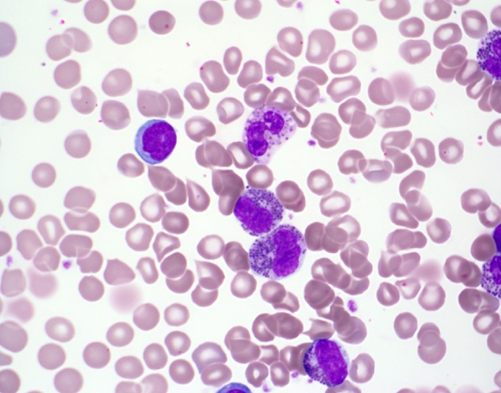

A 3-month-old infant has a CBC performed and is referred to a pediatric hematologist because of the leukocyte abnormalities noted on the peripheral smear. What class of lysosomal storage disease does the smear suggest?

A. Sphingolipidoses (eg, Gaucher, Niemann-Pick)
B. Mucopolysaccharidoses (eg, Hurler, Hunter syndrome)
C. Acid lipase deficiency (eg, Wolman)
D. Neuronal ceroid lipofuscinoses
E. Metachromatic leukodystrophy

Explanation
The prominent azurophilic granulations seen in the leukocytes are an example of the Alder-Reilly anomaly. This finding is seen in patients with mucopolysaccharidoses, where there is lysosomal buildup of mucopolysaccharide due to impaired catabolism. Types include the following:
- Type 1: Hurler
- Type 2: Hunter
- Type 3: Sanfilippo syndrome
- Type 4: Morquio syndrome
- Type 6: Maroteaux-Lamy syndrome
- Type 7: Sly syndrome

22.
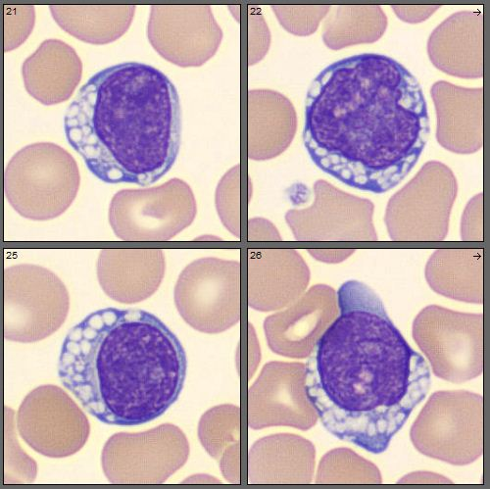

The morphologic findings in these peripheral blood cells are found in what disease category?

A. Lysosomal storage diseases
B. Primary immunodeficiency syndromes
C. Bone marrow failure syndromes
D. Collagen vascular disorders
E. Severe systemic infections

Explanation
The cells shown are lymphocytes with cytoplasmic vacuoles, which should make you think of lysosomal storage disorders. Specific disorders reported to have vacuolated lymphocytes include
- mucopolysaccharidosis
- galactosialidosis
- mucolipidosis
- juvenile neuronal ceroid lipofuscinosis
- GM₁ gangliosidoses

23.
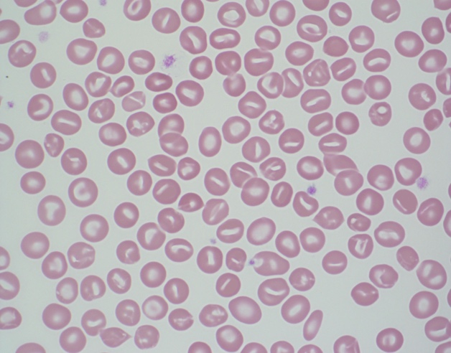

The patient is a 2-month-old infant with pallor, jaundice, and splenomegaly. A CBC is notable for hemoglobin of 7.2 g/dL, mean corpuscular volume (MCV) of 110 fL, mean corpuscular hemoglobin concentration (MCHC) of 24%, and reticulocyte count of 210 k/µL. What is the most likely diagnosis?

A. Hereditary elliptocytosis
B. Neuroacanthosis
C. Pyropoikilocytosis
D. Southeast Asian ovalocytosis
E. Hereditary stomatocytosis

Explanation
Review of the peripheral smear shows many stomatocytes. A stomatocyte is a uniconcave red cell that results in central pallor that looks like a slit or a slightly curved rod. Hereditary stomatocytosis is caused by mutations in Rh-associated glycoprotein, which leads to cation permeable red cells with resultant overhydration of the cell. These cells have greatly increased intracellular Na+. The diagnostic laboratory features include peripheral smear stomatocytes (5% to 50%), hemolysis, macrocytosis, low MCHC, and positive osmotic fragility test.

24.
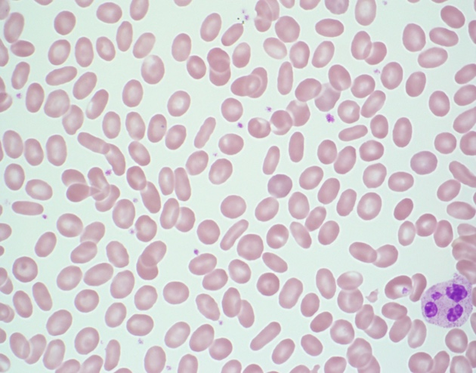

A 5-year-old boy gets a CBC in preparation for a tonsillectomy. The laboratory calls with the finding shown on the smear. Most forms of this condition are inherited in what fashion?

A. X-linked recessive
B. Autosomal dominant
C. Autosomal recessive
D. X-linked dominant
E. Mitochondrial

Explanation
The findings on the peripheral smear include many elliptocytes (ovalocytes). These are rod-shaped cells with two parallel sides of equal lengths and two rounded ends. Central pallor is usually preserved. Normal blood smears can contain a few ovalocytes (fewer than 5%). When seen in large numbers, it is consistent with hereditary elliptocytosis (HE). Typical patients with heterozygous HE are usually asymptomatic. An osmotic fragility test is usually normal. Mutations in α-spectrin, β-spectrin, or protein 4.1 are responsible.

25.
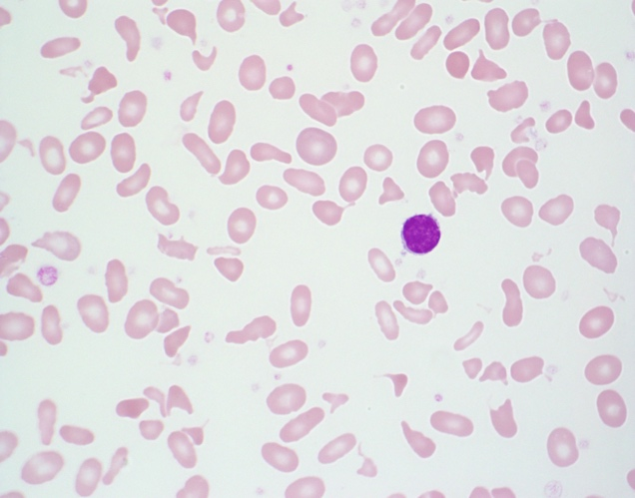

An infant presents with severe anemia, splenomegaly, and hyperbilirubinemia. After the peripheral smear is reviewed, what is the most likely diagnosis?

A. Thalassemia intermedia
B. Hereditary spherocytosis
C. Sideroblastic anemia
D. Hereditary acanthocytosis
E. Hereditary pyropoikilocytosis (HPP)

Explanation
The smear shows anemia with marked poikilocytosis, including schistocytes and elliptocytes. It is consistent with HPP. Essentially, HPP is a more severe form of hereditary elliptocytosis when both parents have hereditary elliptocytosis and each passes on an abnormal allele to their offspring.

